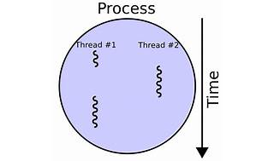

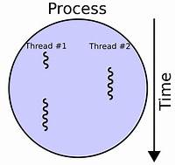

Explore

Certainly! **Multithreading** in computer architecture refers to the ability of a central processing unit (CPU) or a single core in a multi-core processor to provide multiple threads of execution concurrently, supported by the operating system. [Unlike multiprocessing, where multiple complete processing units are involved, multithreading aims to increase utilization of a single core by using thread-level parallelism and instruction-level parallelism1](https://en.wikipedia.org/wiki/Multithreading_%28computer_architecture%29)[2](https://www.educative.io/blog/multithreading-and-concurrency-fundamentals).

Here are **five free reference links** where you can learn more about multithreading:

1. [**GeeksforGeeks: Java Multithreading Tutorial**](https://www.geeksforgeeks.org/java-multithreading-tutorial/): This tutorial covers the basics of multithreading in Java, including thread creation, lifecycle, and synchronization.
2. [**Coursera: Create Your First Multithreaded Application in Java**](https://www.coursera.org/courses?query=multithreading): A practical project-based course on creating multithreaded applications in Java.
3. [**Udemy: Java Multithreading**](https://www.udemy.com/course/java-multithreading/): An ultimate Java multithreading course available for free on Udemy.
4. [**Educative: Multithreading and Concurrency Fundamentals**](https://www.educative.io/blog/multithreading-and-concurrency-fundamentals): Learn the fundamentals of multithreading and concurrent programming.
5. [**FreeCodeCamp: Multithreading in Java**](https://www.freecodecamp.org/news/how-to-get-started-with-multithreading-in-java/): Get started with threads in Java and understand the concept of lightweight processes.

Feel free to explore these resources to enhance your understanding of multithreading! 🚀